Clean Code Principles - Meaningful Names Over Comments
# Source: AI Source: Provided by: [Data Path: Persons Table -> ID Column: 1, Name_En Column: Motasem Essam] -> From: [Chatgpt (GPT‑5 Mini)] on [12/9/2025]
Using clear, descriptive names is often better than writing comments to explain your code. If the code reads like a story, comments become mostly unnecessary.
👉 Names should explain what and why, not just rely on comments to clarify.

🔑 Why Meaningful Names Matter
# Source: AI Source: Provided by: [Data Path: Persons Table -> ID Column: 1, Name_En Column: Motasem Essam] -> From: [Chatgpt (GPT‑5 Mini)] on [12/9/2025]
- Reduces the need for comments
- Makes code self-explanatory
- Helps future developers understand your intent
- Reduces risk of outdated or misleading comments

❌ Bad Example (Relying on Comments)
# Source: AI Source: Provided by: [Data Path: Persons Table -> ID Column: 1, Name_En Column: Motasem Essam] -> From: [Chatgpt (GPT‑5 Mini)] on [12/9/2025]
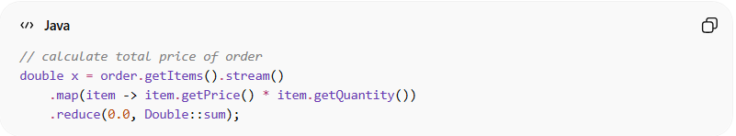
// calculate total price of order
double x = order.getItems().stream()
.map(item -> item.getPrice() * item.getQuantity())
.reduce(0.0, Double::sum);
👉 Issues:
- Variable name x tells nothing
- Comment is needed just to explain the purpose

✅ Good Example (Descriptive Names, No Comment Needed)
# Source: AI Source: Provided by: [Data Path: Persons Table -> ID Column: 1, Name_En Column: Motasem Essam] -> From: [Chatgpt (GPT‑5 Mini)] on [12/9/2025]
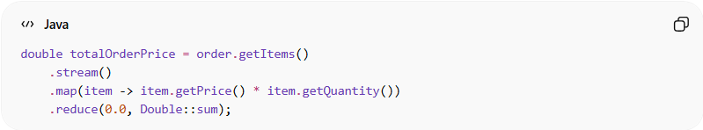
double totalOrderPrice = order.getItems()
.stream()
.map(item -> item.getPrice() * item.getQuantity())
.reduce(0.0, Double::sum);
👉 Clear and self-explanatory: no comment needed

❌ Another Bad Example
# Source: AI Source: Provided by: [Data Path: Persons Table -> ID Column: 1, Name_En Column: Motasem Essam] -> From: [Chatgpt (GPT‑5 Mini)] on [12/9/2025]
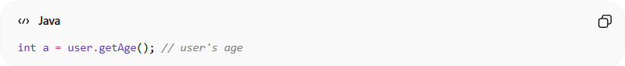
int a = user.getAge(); // user's age

✅ Good Example
# Source: AI Source: Provided by: [Data Path: Persons Table -> ID Column: 1, Name_En Column: Motasem Essam] -> From: [Chatgpt (GPT‑5 Mini)] on [12/9/2025]
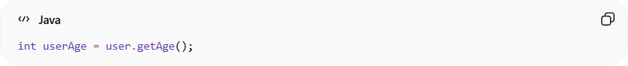
int userAge = user.getAge();

💡 Key Idea
# Source: AI Source: Provided by: [Data Path: Persons Table -> ID Column: 1, Name_En Column: Motasem Essam] -> From: [Chatgpt (GPT‑5 Mini)] on [12/9/2025]
If you need a comment to explain a variable, function, or class, the name is probably bad.

🚫 Common Mistakes
# Source: AI Source: Provided by: [Data Path: Persons Table -> ID Column: 1, Name_En Column: Motasem Essam] -> From: [Chatgpt (GPT‑5 Mini)] on [12/9/2025]
- Using short or vague names like temp, data, flag
- Over-commenting obvious logic
- Letting comments become outdated
- Hiding intent behind cryptic names

🧾 Summary
# Source: AI Source: Provided by: [Data Path: Persons Table -> ID Column: 1, Name_En Column: Motasem Essam] -> From: [Chatgpt (GPT‑5 Mini)] on [12/9/2025]
Meaningful names make your code:
- Easier to read and maintain
- Less dependent on comments
- Self-documenting and professional

